$ kubectl get pods

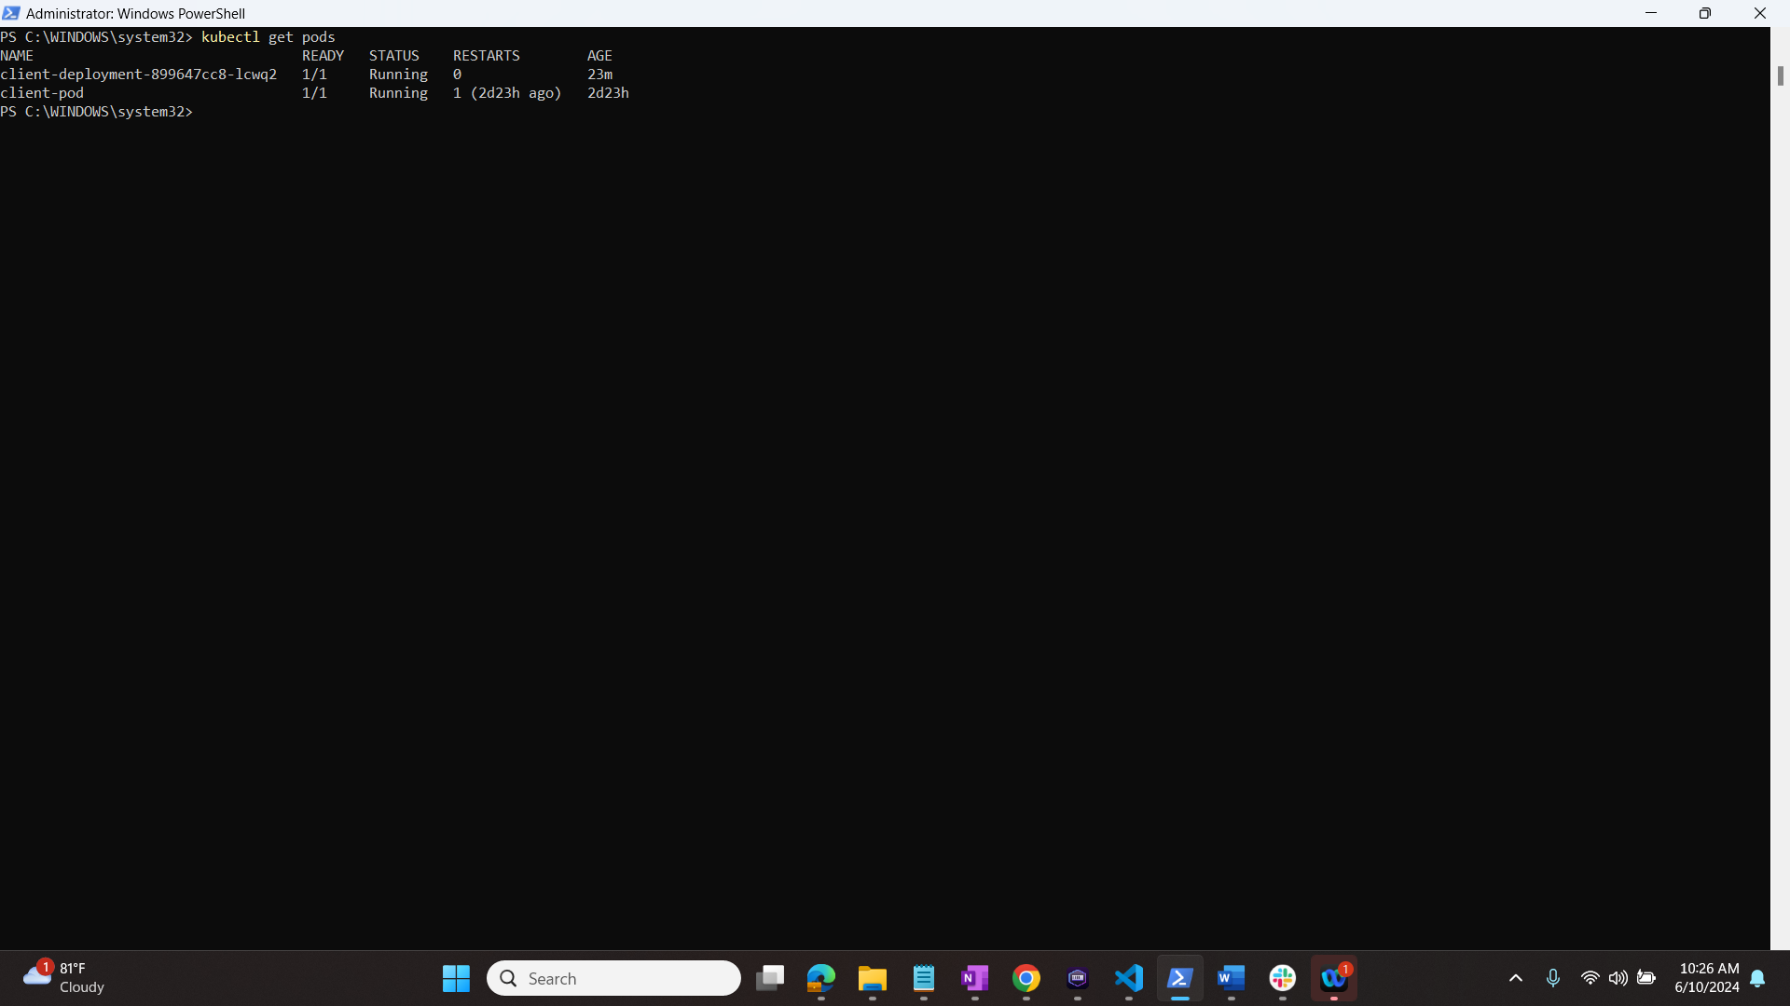

$ kubectl get services

$ kubectl get deployments

